The Nazi Ideology of Race

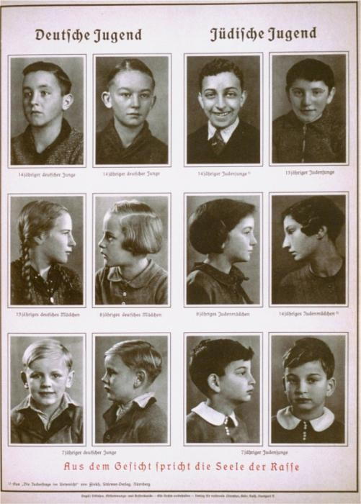

Racist illustration
This 1938 racist illustration compares “German Youth” with “Jewish Youth.” It is subtitled, “From the face speaks the soul of the race.” It comes from Alfred Vogel's text Inheritance and Racial Hygiene. The Nazis used racist theories to label groups of people as inferior and as the "enemy." They Nazis claimed that "superior" races had not just the right but the obligation to subdue and even exterminate "inferior" ones.

Adolf Hitler, the Führer (Leader) of the Nazi Party, formulated and articulated the ideas that came to be known as Nazi ideology. He thought of himself as a deep and profound thinker, convinced that he had found the key to understanding an extraordinarily complex world.
Hitler believed that a person's characteristics, attitudes, abilities, and behavior were determined by his or her so-called racial make-up. In Hitler's view, all groups, races, or peoples (he used those terms interchangeably) carried within them traits that were passed from one generation to the next. No individual could overcome the qualities of race. All of human history could be explained in terms of racial struggle.
In formulating their ideology of race, Hitler and the Nazis drew upon the ideas of the German social Darwinists of the late 19th century. Like the social Darwinists before them, the Nazis believed that human beings could be classified collectively as “races,” with each race bearing distinctive characteristics that had been passed on genetically since the first appearance of humans in prehistoric times. These inherited characteristics related not only to outward appearance and physical structure, but also shaped internal mental life, ways of thinking, creative and organizational abilities, intelligence, taste and appreciation of culture, physical strength, and military prowess.
The Nazis also adopted the social Darwinist take on Darwinian evolutionary theory regarding the “survival of the fittest.” For the Nazis, survival of a race depended upon its ability to reproduce and multiply, its accumulation of land to support and feed that expanding population, and its vigilance in maintaining the purity of its gene pool, thus preserving the unique “racial” characteristics with which “nature” had equipped it for success in the struggle to survive. Since each “race” sought to expand, and since the space on the earth was finite, the struggle for survival resulted “naturally” in violent conquest and military confrontation. Hence, war—even constant war—was a part of nature, a part of the human condition.
To define a race, the social Darwinists affixed stereotypes, both positive and negative, of ethnic group appearance, behavior, and culture. These stereotypes were allegedly unchangeable and rooted in biological inheritance. They remained unchanged over time and were immune to changes in environment, intellectual development, or socialization. For the Nazis, assimilation of a member of one race into another culture or ethnic group was impossible because the original inherited traits could not change: they could only degenerate through so-called race-mixing.

Targeted Groups
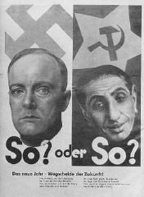The Nazis defined Jews as a “race.” Regarding the Jewish religion as irrelevant, the Nazis attributed a wide variety of negative stereotypes about Jews and “Jewish” behavior to an unchanging biologically determined heritage that drove the “Jewish race,” like other races, to struggle to survive by expansion at the expense of other races.
While it classified Jews as the priority “enemy,” the Nazi ideological concept of race targeted other groups for persecution, imprisonment, and annihilation. These groups included Roma (Gypsies), people with disabilities, Poles, Soviet prisoners of war, and Afro-Germans. The Nazis also identified political dissidents, Jehovah’s Witnesses, homosexuals, and so-called asocials as enemies and security risks either because they consciously opposed the Nazi regime or some aspect of their behavior did not fit Nazi perceptions of social norms. They sought to eliminate domestic non-conformists and so-called racial threats through a perpetual self-purge of German society.
The Nazis believed that superior races had not just the right but the obligation to subdue and even exterminate inferior ones. They believed that this struggle of races was consistent with the law of nature. The Nazis pursued a strategic vision of a dominant German race ruling subject peoples, especially the Slavs and the so-called Asiatics (by which they meant the peoples of Soviet Central Asia and the Muslim populations of the Caucasus region), whom they judged to be innately inferior. For purposes of propaganda, the Nazis often framed this strategic vision in terms of a crusade to save western civilization from these “eastern” or “Asiatic” barbarians and their Jewish leaders and organizers.

https://encyclopedia.ushmm.org/content/en/article/victims-of-the-nazi-era-nazi-racial-ideology

